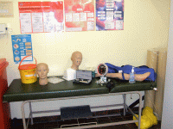
PLAB 2 practice at Reache

Booking rooms
There are regular sessions appropriate for PLAB 2. These are the communication (PLAN) sessions on Wednesday afternoons and the practical sessions on Friday afternoon. Members who are preparing for PLAB 2 are expected to attend at least 80% of these.
Members can also practice at other times using the equipment. If possible, you can book a room by asking Marilyn. If the rooms are not available to book in advance, it is usually possible to find a room on the day. It is expected that all the members preparing for PLAB 2 will be invited to any practice session. Reache expects members to be helping each other.

Tutor support
Tutors facilitate the PLAN and Friday afternoon practical skills sessions. They may also be available to help if it is requested in advance.

Equipment cupboard and supplies
The equipment cupboard contains supplies of the consumables that you need. If any of the supplies run out, don’t panic, let Mick or Marilyn know right away - there is a back up store cupboard as well, which only the tutors have access to. Please let us know if you have used the last item of any stock, so we can replace it.
- If a piece of equipment uses batteries and the batteries are dead let us know so that we can replace them – DON’T just put it back in the box and use another one
- If something is broken or missing LET US KNOW so that we can replace it
- ALWAYS PUT EQUIPMENT BACK in its box, in the place you took it from

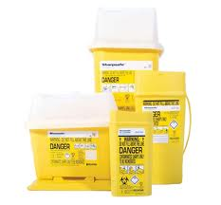
Disposal of waste
Any sharps, such as needles should be put into a Sharps bin IMMEDIATELY after use. Other waste can go into an ordinary black bag.
Note: in clinical practice, there are Yellow bags which are to be used for non-sharp waste that has been in contact with a patient’s body fluids.

Resources
There are many web sites and books which can give you some guidance about clinical skills. Here are some to start you off:
http://www.gmc-uk.org/doctors/plab/23450.asp
http://reache.wordpress.com/links-to-resources/plab-2-resources/
It is best to use several different resources. Some may be good for respiratory examination, others for Primary survey, and so on. If you find others that you find helpful, please let us know. We are always happy to hear about things which can help other students.

Don’t forget to revise anatomy as well as the steps of an examination. This will help you to:
- remember the examination
- link your findings to possible diagnoses
- not look foolish

